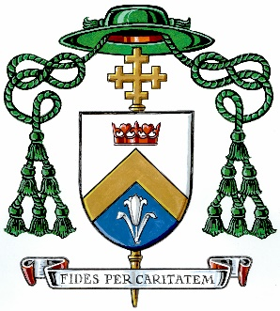

FROM THE VINEYARD

Newsletter No. 314; January 23, 2025

THE FILIPPINO COMMUNITY capped off their celebration of the “Santo Nino” (Holy Child) last Sunday at Immaculate Conception Parish in Peterborough. It was a joyful gathering both at the Mass and the Dinner held afterwards in the Parish Hall. Dancing is a major feature of this festival and though I didn’t join in, I was happy to observe! Congratulations to the all the organizers for putting together a well-attended and successful festival this year.

THIS SUNDAY IS “SUNDAY OF THE WORD OF GOD.” When Pope Francis instituted this celebration in 2019, he wrote, “devoting a specific Sunday of the liturgical year to the word of God can enable the Church to experience anew how the risen Lord opens up for us the treasure of his word and enables us to proclaim its unfathomable riches before the world.” The theme for this year is “The Word of Christ Dwells Among You” (Col 3:16) and the resource book may be found here. An excellent article from the U.S. bishops, “Sharing the Word of God at Home,” may be accessed at their website.

OUR LADY OF THE WAYSIDE CATHOLIC SCHOOL in Peterborough is seeking an Academic Principal. Information about the position, its responsibilities and candidate qualifications can be found here.

I WAS PLEASED TO PRESENT AT THE CATHEDRAL’S RCIA (Rite of Chrisitan Initiation of Adults) last week. They have a large group seeking initiation into the Church, whether through baptism or reception into full communion. More than 20 candidates have been gathering Tuesday nights at Bishop Doyle Hall for instruction and faith formation. That is the largest group I can recall, and it is heartening to see this level of interest and engagement. Please pray for candidates pursuing the R.C.I.A. across our diocese, as they study together and prepare for the Easter sacraments.

THE LATEST EDITION OF THE CATHOLIC HERALD came out just before Christmas. I am a little late for “read all about it,” but I encourage you to check it out online if you did not get a hard copy at your parish. You will find a host of good articles including a Jubilee recap, an overview of the work of our Refugee office, and a parish profile of St. Thomas More in Millbrook. Sincere thanks to all our contributors for making The Catholic Herald such an informative and inspiring read!

SPEAKING OF ST. THOMAS MORE PARISH, I am filling in there for a few weeks (and at St. Bernadette’s mission in North Nestleton) as we prepare to welcome a new pastor. I want to thank the parishioners for their good efforts and very kind welcome, and Father Peter Wayow, CSSp, who provided substitute ministry in the parish for the past four months.

Fraternally,
† Daniel

