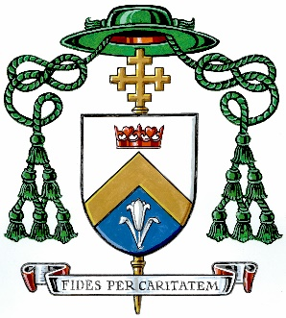

FROM THE VINEYARD

Newsletter No. 313; January 16, 2025

I CELEBRATED MASS AT TWO LONG-TERM CARE CENTERS in Parry Sound yesterday: Lakeland and Belvedere Heights. As part of the Jubilee Year celebrations, I have been trying to visit places where they don’t see the bishop that often, including care facilities and prisons. I was grateful be hosted by Father Jerry Tavares and a committed team of volunteers who handle the logistics of these Masses and who show great pastoral care for the residents.

WE ALSO MARK THE JUBILEE THIS SUNDAY WITH A SOLIDARITY MASS for the World Day of the Poor. I’m looking forward to being at St. Joseph’s Parish in Bowmanville for this event, co-sponsored by Development and Peace-Caritas Canada. Following the Sunday, 11:00 a.m. Mass, all are invited to a light lunch afterwards and a talk by guest speaker, Hector Acero Ferrer, from the Institute for Christian Studies.

THE WORLD DAY OF THE POOR WAS INSTITUTED BY POPE FRANCIS in 2016 and first observed in November of 2017. At the conclusion of the Extraordinary Jubilee of Mercy, Pope Francis took this step so that “throughout the world Christian communities can become an ever-greater sign of Christ’s charity for the least and those most in need.” We mark this day each year on the 33rd Sunday in Ordinary Time, reflecting on our call serve the poor and build a better world. Pope Leo’s message for the World Day of the Poor, on the theme “You are my Hope,” can be found here.

THE DIOCESE OF PETERBOROUGH is seeking a Stewardship and Development Officer. More information about this position, the responsibilities, qualifications and compensation can be found at our Diocesan website.

OUR LADY OF THE WAYSIDE CATHOLIC SCHOOL is marking its 30th Anniversary! I look forward to celebrating a Mass of Thanksgiving with the school community next Thursday at 5:00 p.m. at our Cathedral. The Mass will be followed by a reception, dinner and presentation at Bishop Doyle Hall. Congratulations to all at Our Lady of the Wayside as they celebrate three decades of “faith and formation through classical Catholic education.”

THE ANNUAL MEMORIAL MASS FOR PVNC CATHOLIC SCHOOL BOARD was offered at our Cathedral on Wednesday evening. Staff and many people affiliated with our board came out to pray in a special way for members of the PVNC community who passed away in the past year. It was a beautiful liturgy and prayerful liturgy where the names of staff, students and family members were read out. Eternal rest grant unto them, O Lord.

MARK YOUR CALENDARS! The Jubilee Year of Hope officially closes in our Diocese with a Mass at the Cathedral on the Feast of Holy Family, Sunday, December 28, at 10:30 a.m. Priests, deacons, the lay faithful and religious are all very welcome to participate.

Fraternally,
† Daniel

